**A PRELIMINARY REPORT ON**

**Blockchain Technology Mini Project**

SUBMITTED TO THE SAVITRIBAI PHULE PUNE UNIVERSITY, PUNE IN THE PARTIAL FULFILLMENT OF THE REQUIREMENTS FOR THE ACADEMIC OF

**FOURTH YEAR OF COMPUTER ENGINEERING**

**SUBMITTED BY**

**Harsh Bhattad BBCO20104**



**DEPARTMENT OF COMPUTER ENGINEERING**

**DR. D.Y.PATIL INSTITUTE OF ENGINEERING, MANAGEMENT & RESEARCH**

**AKURDI, PUNE 411044**

**SAVITRIBAI PHULE PUNE UNIVERSITY**

AY 2023 -2024



**CERTIFICATE**

This is to certify that the Mini Project report of

**Blockchain Technology**

Submitted by

**Harsh Bhattad TBCO20104**

**is a bonafide student of this institute and the work has been carried out by them under the supervision of Mrs. Deepali Jawale and it is approved for the partial fulfillment of the requirement of Savitribai Phule Pune University, for the award of the Fourth year degree of Computer Engineering.**

**Mrs. Deepali Jawale** **M/s. P. P. Shevatekar**

Guide Head

Department of Computer Engineering Department of Computer Engineering

Place: Pune

Date:

**ABSTRACT**

In this mini project, In an era characterized by the digital transformation of healthcare, the development of a blockchain-based application for managing health-related medical records stands as a pivotal technological advancement. This project embarks on the journey of creating a secure, transparent, and patient-centric platform that leverages blockchain technology to revolutionize the storage, management, and sharing of medical records.

Our endeavor involves the design and implementation of a blockchain-based system that ensures the integrity, privacy, and interoperability of medical records while empowering individuals with greater control over their personal health data. By employing blockchain's distributed ledger technology, data immutability, and cryptographic security, we enable patients, healthcare providers, and authorized parties to access, update, and share medical records seamlessly and with the highest level of trust.

This abstract encapsulates the essence of our project, showcasing the potential for blockchain to reshape the healthcare landscape, enhance patient care, streamline medical processes, and fortify data security, ultimately advancing the intersection of technology and health for a brighter, more efficient, and patient-centric future.

**ACKNOWLEDGEMENT**

First and foremost, I would like to thank my guide for this Mini Project, **Mrs. Deepali Jawale** for the valuable guidance and advice. She inspired us greatly to work in this seminar. Her willingness to motivate us contributed tremendously to our seminar work. I also would like to thank her for showing me some examples that related to the topic of my Mini Project.

Apart from our efforts, the success of any seminar depends largely on the encouragement and guidelines of many others. So, we take this opportunity to express my gratitude to **M/s. P. P. Shevatekar**, Head of the Department of Computer Engineering, Dr. D Y Patil Institute of Engineering, Management And Research, Akurdi has been instrumental in the successful completion of this seminar work.

The guidance and support received from all the members who contributed and who are contributing to this seminar work were vital for the success of the seminar. I am grateful for their constant support and help.

**Harsh Bhattad**

Student Name

(B.E. COMPUTER ENGG.)

**TABLE OF CONTENT**

|  |  |  |
| --- | --- | --- |
| **Sr No.** | **Content** | **Page No.** |
| 1 | Introduction | 6 - 8 |
|  | 1.1. Introduction | 6 |
|  | 1.2. Problem Statement | 7 |
|  | 1.3. Objectives | 7 |
| 2 | Methodology | 9 - 10 |
| 3 | Implementation | 11 - 17 |
| 4 | Conclusion | 18 |

**CHAPTER 1: INTRODUCTION**

**1.1. INTRODUCTION**

In an era defined by rapid technological advancements and the growing need for secure and accessible healthcare information, the development of a blockchain-based application for health-related medical records represents a pioneering leap towards revolutionizing the healthcare industry. Blockchain technology, initially popularized by its role in cryptocurrencies, has evolved into a robust and versatile platform that offers unparalleled potential for transforming the way we manage and share sensitive medical data.

The significance of healthcare records cannot be overstated. They are the lifeblood of the medical profession, serving as the primary means through which healthcare providers access patient histories, track treatment progress, and make informed decisions. However, the current healthcare data landscape is fraught with challenges, including security vulnerabilities, interoperability issues, and patient data fragmentation. It is against this backdrop that the concept of blockchain-based healthcare applications emerges, promising a future where health records are not only secure, but also highly efficient, transparent, and easily accessible to authorized parties.

This project embarks on a journey to harness the potential of blockchain technology to create a transformative healthcare application. In the pages that follow, we will delve into the key components and considerations of this undertaking, from the fundamentals of blockchain technology and its application in healthcare to the practical implementation of a secure, decentralized system for storing and managing health-related medical records. This application has the power to enhance patient outcomes, reduce fraud, streamline data sharing among healthcare providers, and empower patients with greater control over their health information.

As we navigate through the development of this blockchain-based application for health-related medical records, we will explore the technology's capacity to improve the quality and accessibility of healthcare services while safeguarding the confidentiality and integrity of patients' vital medical information. It is a journey into the future of healthcare, where data security and patient privacy meet the promise of digital innovation, ultimately reshaping the way we approach healthcare record management.

**1.2. PROBLEM STATEMENT**

The problem statement for this project is in an era marked by the increasing digitization of healthcare, the secure and efficient management of medical records has become a critical challenge. Traditional paper-based medical record systems often lead to issues such as data fragmentation, redundancy, security vulnerabilities, and limited patient accessibility. To address these concerns, there is a pressing need to develop a blockchain-based application tailored for health-related medical records.

**1.3. OBJECTIVE**

Enhance Data Security: Create a secure and tamper-proof platform for storing and managing health-related medical records, ensuring the utmost data security and privacy for patients and healthcare providers.

Improve Data Accessibility: Facilitate easy and controlled access to medical records, enabling authorized healthcare professionals, patients, and relevant stakeholders to retrieve and share information efficiently.

Enhance Data Interoperability: Develop a standardized format for medical records that supports interoperability between various healthcare institutions and systems, promoting seamless data exchange and patient care coordination.

Empower Patients: Empower patients to have greater control over their own medical records, allowing them to share data securely with healthcare providers and other authorized entities as needed.

Reduce Administrative Overhead: Streamline administrative processes by automating data verification, eliminating redundant paperwork, and reducing the risk of errors in medical records.

Ensure Data Integrity: Utilize blockchain's immutability to guarantee the integrity of medical records, preventing unauthorized alterations and ensuring a complete and trustworthy medical history.

Enhance Auditability: Create a transparent and auditable system for healthcare institutions and regulatory bodies to verify and audit medical records with ease.

Comply with Regulatory Requirements: Ensure that the application adheres to relevant healthcare data privacy regulations, such as HIPAA in the United States or GDPR in the European Union.

Facilitate Research: Enable medical researchers to access de-identified data for medical studies while preserving patient privacy and security.

Optimize Workflow: Improve the efficiency of healthcare providers by reducing the time and effort required to access and update patient records.

Promote Data Consent Management: Implement robust consent management features, allowing patients to control who can access their medical records and for what purposes.

Pilot and Validate: Conduct pilot implementations to validate the effectiveness of the blockchain-based application within real healthcare settings, ensuring it meets the needs of both providers and patients.

Scalability and Performance: Design the application to scale efficiently to accommodate a growing number of users and increasing data volume, while maintaining acceptable performance levels.

Educate and Train Users: Develop training programs and materials to educate healthcare professionals, patients, and administrators about the blockchain application, ensuring its optimal utilization.

Evaluate Cost-Efficiency: Assess the cost-effectiveness of implementing blockchain technology for health-related medical records, considering factors such as infrastructure, maintenance, and long-term benefits.

Continual Improvement: Implement a framework for ongoing enhancements and updates to the application, incorporating user feedback and emerging blockchain and healthcare technologies.

**CHAPTER 2: METHODOLOGY**

Developing a blockchain-based application for health-related medical records is a complex and highly sensitive task that demands careful planning, robust security measures, and adherence to legal and ethical standards. The following methodology outlines a structured approach for creating such an application:

1. **Understanding the Domain:**
   * Gain a deep understanding of the healthcare industry, medical record management, regulatory compliance, and privacy concerns. Collaborate with healthcare professionals and legal experts to ensure accurate domain knowledge.
2. **Project Definition:**
   * Define the scope, objectives, and target users of the blockchain-based application. Identify key stakeholders, such as healthcare providers, patients, and administrators.
3. **Regulatory Compliance:**
   * Ensure compliance with healthcare regulations, such as HIPAA (Health Insurance Portability and Accountability Act) in the United States, and other relevant laws in your region.
4. **Privacy and Security Design:**
   * Implement robust security and privacy features. Use encryption, access controls, and secure data transmission methods to protect sensitive medical data.
5. **Blockchain Platform Selection:**
   * Choose a suitable blockchain platform (e.g., Ethereum, Hyperledger Fabric, or a custom blockchain) based on your project requirements. Evaluate the platform's scalability, performance, and consensus mechanisms.
6. **Data Schema and Smart Contracts:**
   * Design the data schema for storing medical records on the blockchain. Develop smart contracts to manage access control and record sharing. Ensure the smart contracts are auditable and tamper-resistant.
7. **Identity Management:**
   * Implement a secure identity management system for patients, healthcare providers, and administrators. Use cryptographic methods to protect user identities and ensure data integrity.
8. **User Interface Design:**
   * Develop user-friendly interfaces for patients to access and control their medical records, and for healthcare providers to add, modify, and review records. Implement role-based access controls.
9. **Blockchain Node Setup:**
   * Set up the blockchain network and nodes. Configure node security and maintain regular backups. Decide on the type of consensus mechanism (e.g., Proof of Work or Proof of Authority).
10. **Data Integration:**
    * Integrate the application with healthcare systems, Electronic Health Records (EHR) systems, and external data sources to facilitate real-time data updates and interoperability.
11. **Testing and Quality Assurance:**
    * Conduct extensive testing, including unit testing, integration testing, security testing, and penetration testing to identify and fix vulnerabilities.
12. **Deployment and Scaling:**
    * Deploy the application in a secure and scalable environment. Consider the use of cloud-based infrastructure for flexibility and redundancy.
13. **User Training:**
    * Train users, including healthcare providers and patients, on how to use the application securely and efficiently.
14. **Performance Monitoring:**
    * Implement monitoring tools to track the performance of the blockchain network, application, and database. Set up alerts for anomalies or security breaches.
15. **Ongoing Maintenance:**
    * Provide regular updates, security patches, and improvements to the application. Ensure that it continues to meet evolving healthcare standards and regulations.
16. **User Support and Feedback:**
    * Establish a support system for users to report issues and provide feedback. Address concerns promptly and continuously improve the application based on user input.
17. **Audit and Compliance Checks:**
    * Regularly audit the blockchain for data integrity, and conduct compliance checks to ensure adherence to healthcare regulations.
18. **Legal and Ethical Considerations:**
    * Consult legal experts to ensure that the application complies with changing regulations and ethical standards, especially regarding data ownership, consent, and access.

.

**CHAPTER 3: IMPLEMENTATION**

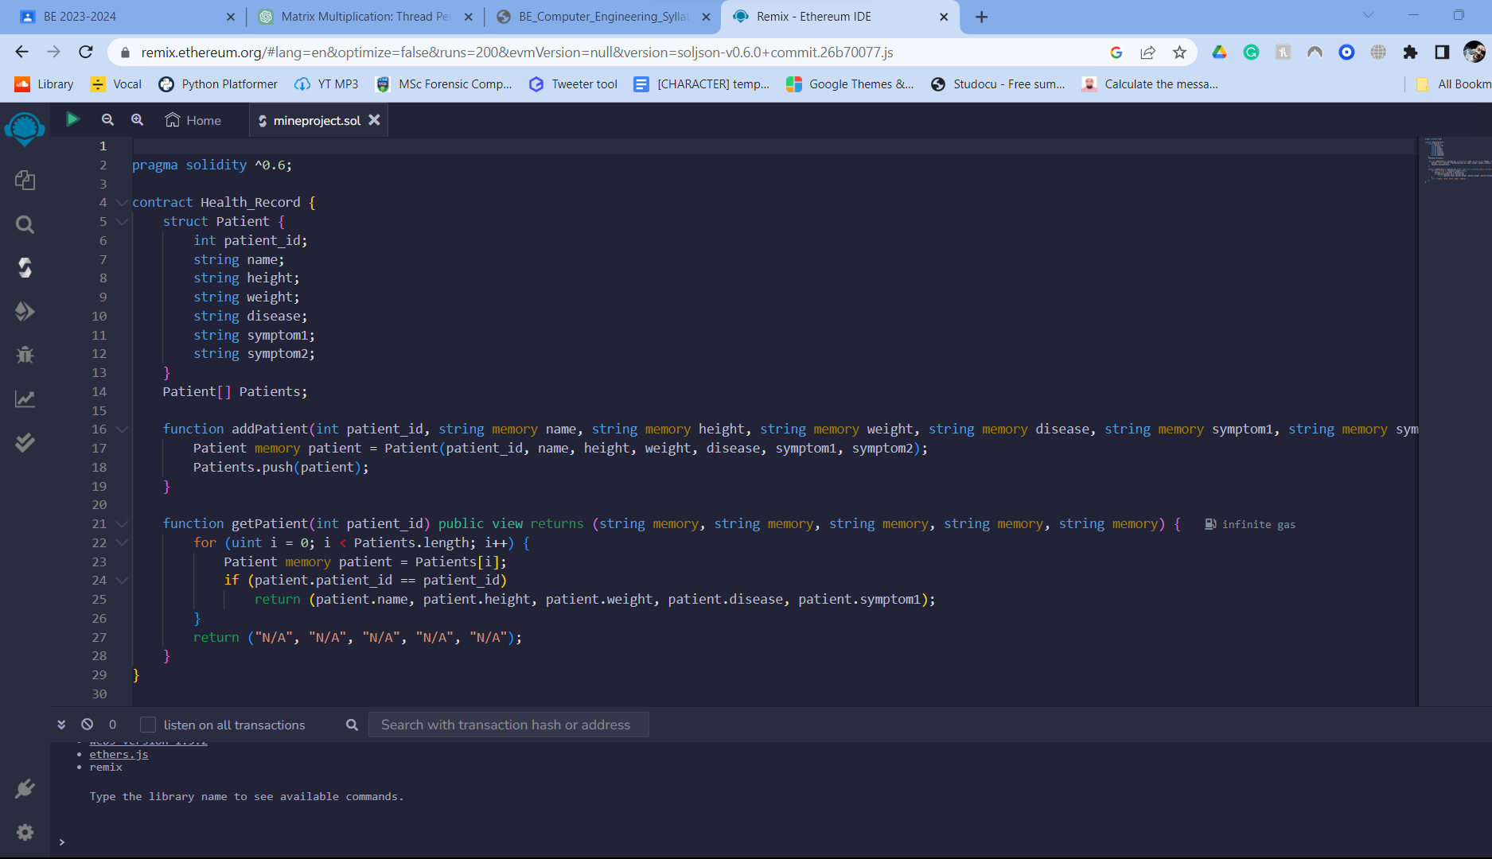

**Deployment**

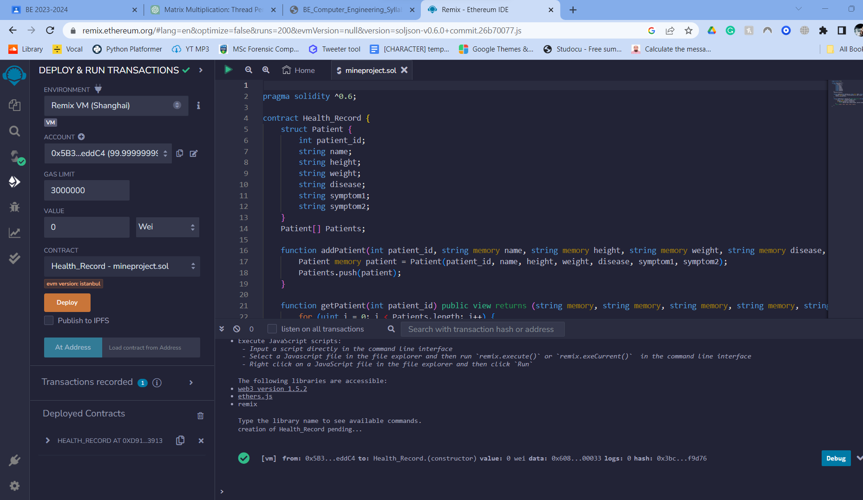

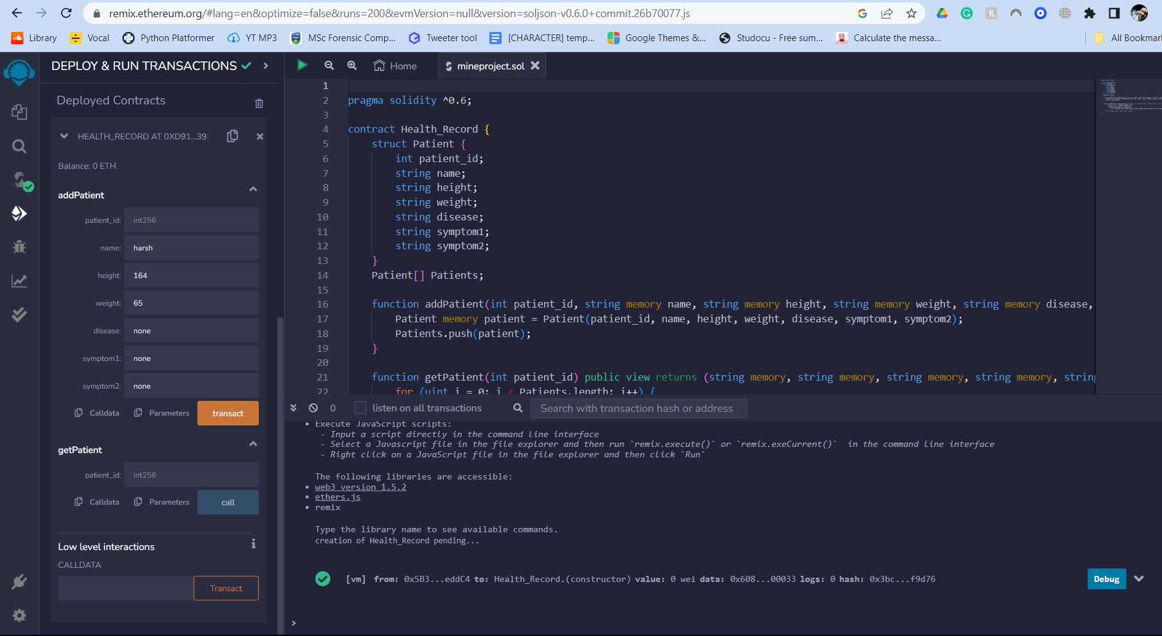

**CHAPTER 4: CONCLUSION**

1. **Enhanced Security and Data Integrity:** Blockchain technology, with its decentralized and tamper-resistant ledger, addresses critical issues surrounding the security and integrity of medical records. By providing a transparent and immutable record of patient information, the application significantly reduces the risk of data breaches and unauthorized access. This offers patients, healthcare providers, and other stakeholders peace of mind regarding the confidentiality and accuracy of medical data.
2. **Patient Empowerment:** The blockchain-based health records application empowers patients to have greater control over their medical information. Patients can grant and revoke access to their records, ensuring that only authorized healthcare professionals can view and update their data. This not only promotes patient privacy but also enables individuals to actively participate in their healthcare decisions.
3. **Streamlined Data Sharing:** Healthcare providers and institutions benefit from streamlined and secure data sharing. The application facilitates real-time access to a patient's complete medical history, reducing the risk of duplicate tests, medical errors, and delays in care. This efficiency in data sharing can be a lifesaver in emergency situations.
4. **Interoperability and Standardization:** Blockchain technology fosters interoperability by creating a common platform for healthcare data. This promotes standardization in data formats and protocols, ensuring that different healthcare systems can seamlessly exchange information. As a result, the healthcare ecosystem becomes more efficient and cost-effective.
5. **Research and Analytics:** Blockchain-based healthcare records provide rich datasets for research and analytics. With patient consent, de-identified data can be used for medical research, epidemiological studies, and treatment efficacy assessments. This not only advances medical science but also leads to better patient outcomes.
6. **Challenges and Considerations:** It is crucial to acknowledge the challenges, including regulatory compliance, data privacy, and scalability, when developing and deploying blockchain applications in healthcare. Addressing these challenges requires close collaboration between technology experts, healthcare professionals, and policymakers.

In conclusion, the development of a blockchain-based application for health-related medical records marks a transformative step toward a more secure, patient-centric, and efficient healthcare ecosystem. It aligns with the broader global trend of digitizing and modernizing healthcare delivery. As the technology matures and the healthcare industry continues to adapt, this application has the potential to revolutionize the way healthcare data is managed, shared, and utilized, ultimately leading to better healthcare outcomes for individuals and communities.